Q1

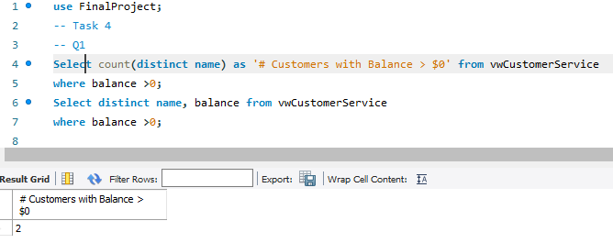

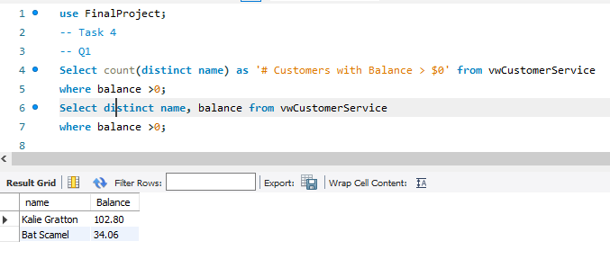

Q2 –Looked at previous readings too

Q3

Q4

Q5

Q6

Q7

Q8

4.2

Q1

Q2



Q3



Q4



